Infosys big data session:

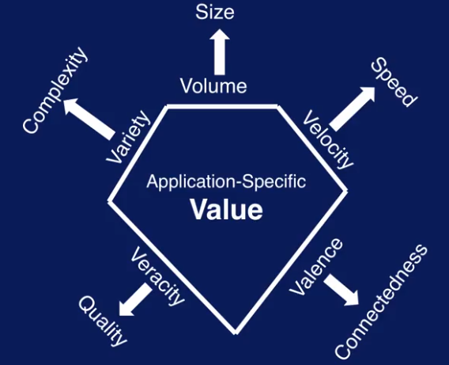

Urchin

Google Analytics -> studies the web traffic.

Cross saling -> on different product, suggesting

Up saling -> on same product, better suggestion

Collaborative Filtering -> group preference indicating personal preference..

Big Data - Volume, velocity, variety, veracity, value

|  |
| --- |
| Pig |Hive |
| Map Reduce |
| YARN |
| HDFS |

Pig and Hive don’t talk to each other.. Pig talks to Map reduce similarly Hive talks to Map Reduce.

YARN -> Resource allocator..

PIG -> high level scripting programming language -> internally converts to Map Reduce

HIVE -> Hive Query language. -> internally converts to Hive.

Impala -> directly interacts with HDFS

Hue -> graphical interface

Zookeeper -> manages

HBase is hadoop’s NoSQL

Sqoop -> moves data from and to hdfs and sql databases while retaining structure of table.

Oozie -> It is your task to make the sequence of MapReduce jobs parallel in case of a complex pipeline. Here, a scheduler tool like Apache Oozie is generally required for constructing this sequence carefully.

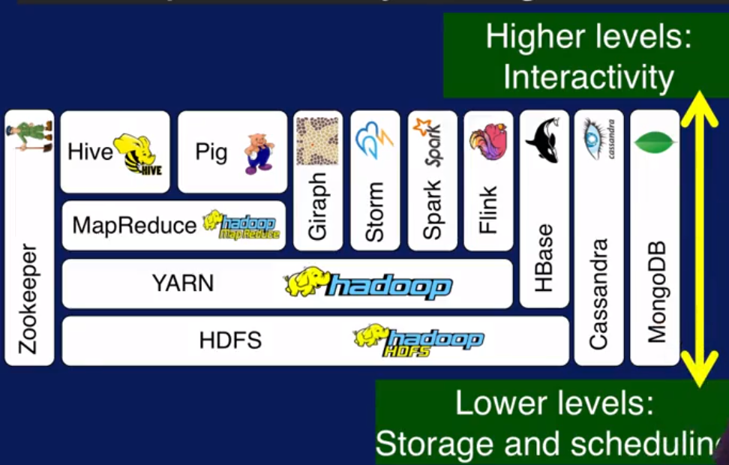

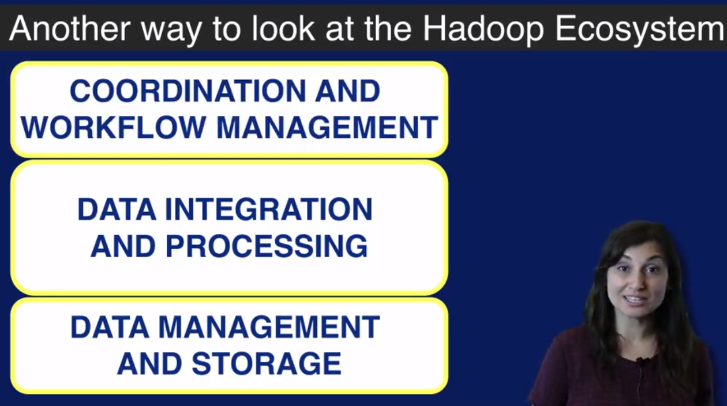

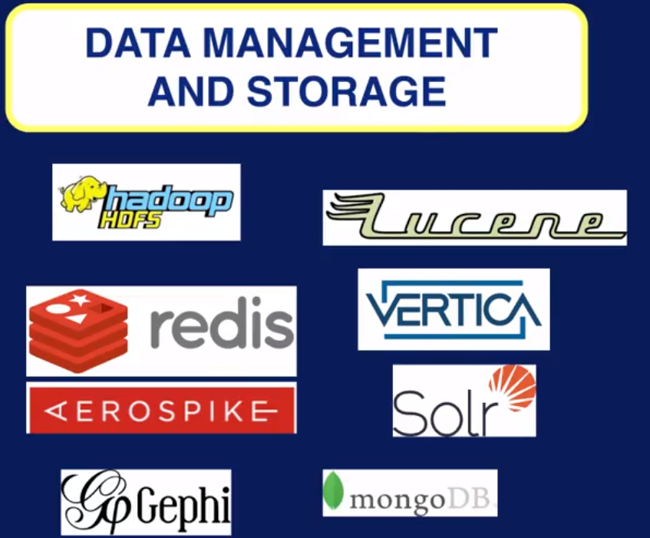

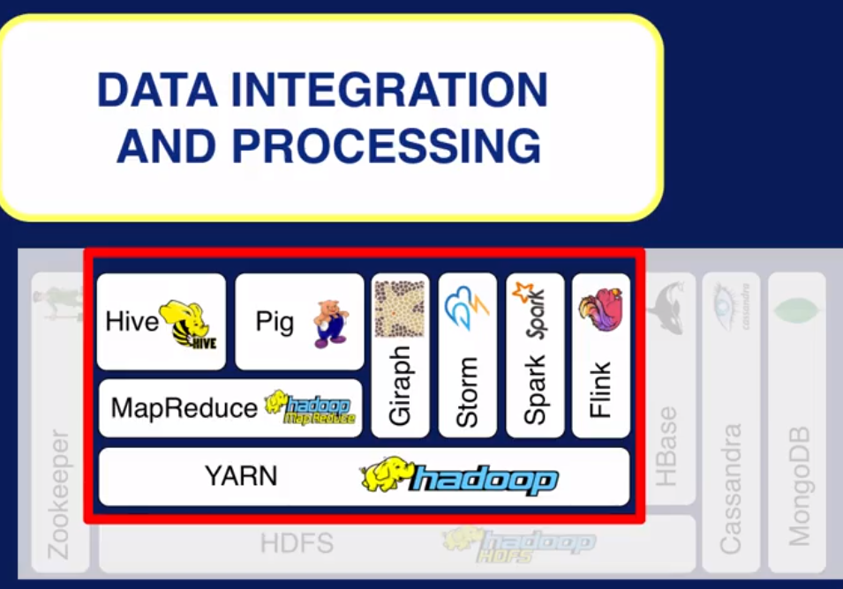

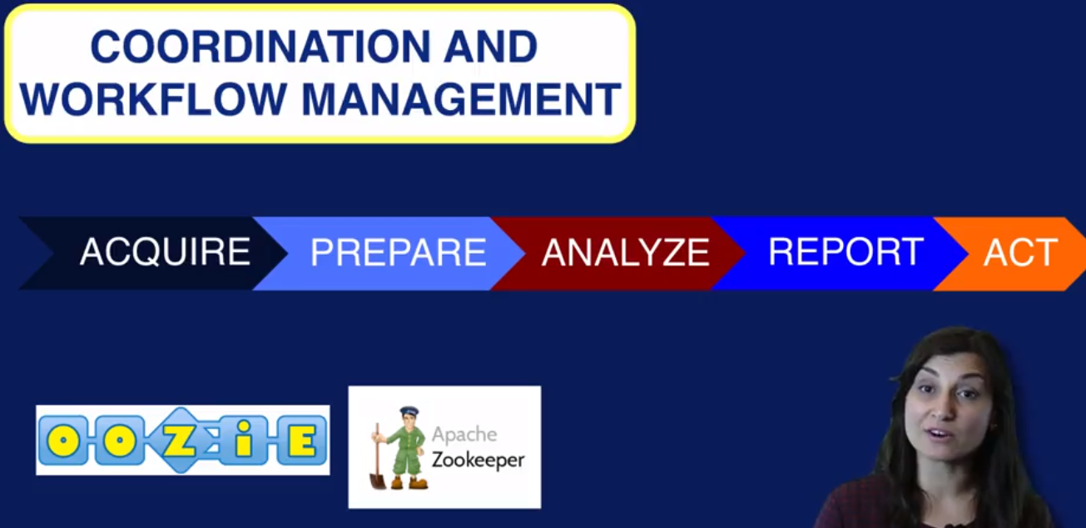

Mesos - Mesos is a open source software originally developed at the University of California at Berkeley. It sits between the application layer and the operating system and makes it easier to deploy and manage applications in large-scale clustered environments more efficiently.

Descriptive Analytics -> What has happened? Eg: quarterly results

Predictive Analytics -> What could happened? Eg:

Prescriptive Analytics -> What shoud we do?

Books:

Competing on Analytics - Thomas

Asking right questions

Simpson’s Paradox:

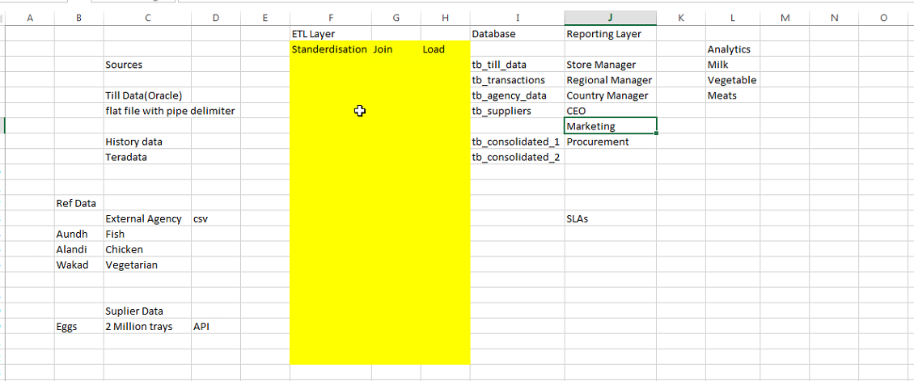

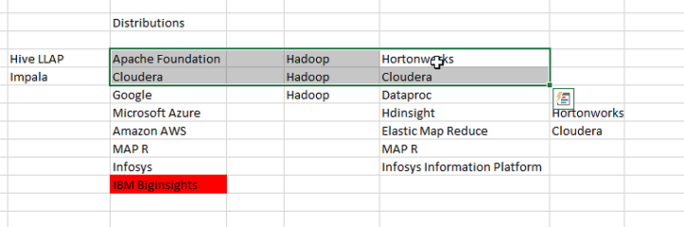

Hortonworks – API is Ambari

Cloudera – API is cloudera manager/director

**Hortonworks cluster credentials:**

mctd1t.ad.infosys.com

root

Infy123

**Cloudera cluster credentials:**

bhucloud05.ad.infosys.com

user1

Infosys1

<https://www.youtube.com/watch?v=9xYfNznjClE>

**CRISP – DM: CROSS Industry Standard Process for Data Mining:**

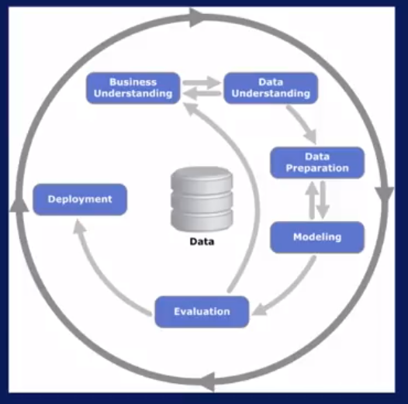

**Skew kurtosis**

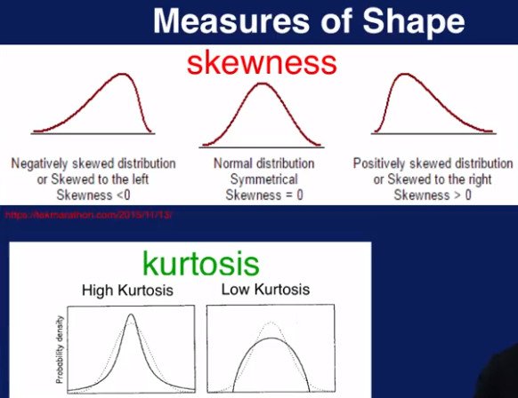

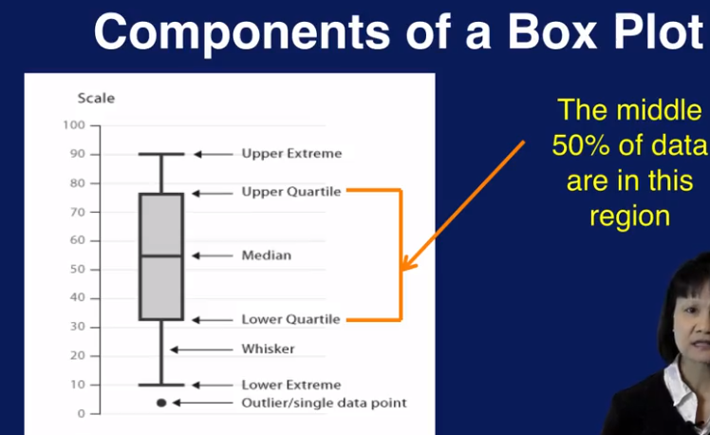

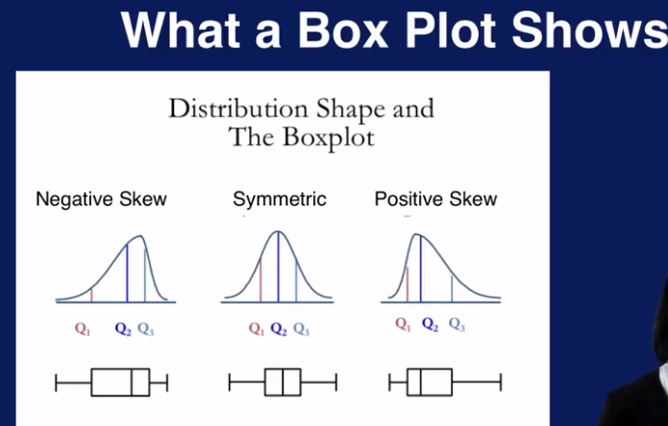

**KNIME -** Konstanz Information Miner

**SPARK:**

<https://databricks.com/blog/2016/07/14/a-tale-of-three-apache-spark-apis-rdds-dataframes-and-datasets.html>

Apache Spark Is an open-source cluster computing framework that was initially developed at UC Berkeley in the AMPLab.

Good link: <https://learning.oreilly.com/learning-paths/learning-path-big/9781788997706/>

**Oracle VM VirtualBox** is a free, open source, cross-platform application for creating, managing and running virtual machines (VMs).

Oracle VirtualBox enables you to set up one or more virtual machines (VMs) on a single physical machine, and use them simultaneously, along with the actual machine. Each virtual machine can execute its own operating system, including versions of Microsoft Windows, Linux, BSD, and MS-DOS. You can install and run as many virtual machines as you like – the only practical limits are disk space and memory.

**Main difference between Spark and mapreduce**

|  |  |
| --- | --- |
| **Spark** | **MapReduce** |
| Spark keeps most of the info in memory after transformation. Spark will spill over to disk if the memory is full. | MapReduce writes most data to disk after every map and reduce operation. |
| Uses data from nosql db’s , HDFS, Amazon S3 etc. | Uses data from HDFS. |
| 100 times faster than mapreduce |  |

**Example of MapReduce:**

Let’s look at a simple example. Assume you have five files, and each file contains two columns (a key and a value in Hadoop terms) that represent a city and the corresponding temperature recorded in that city for the various measurement days. Of course we’ve made this example very simple so it’s easy to follow. You can imagine that a real application won’t be quite so simple, as it’s likely to contain millions or even billions of rows, and they might not be neatly formatted rows at all; in fact, no matter how big or small the amount of data you need to analyze, the key principles we’re covering here remain the same. Either way, in this example, city is the key and temperature is the value. Toronto, 20 Whitby, 25 New York, 22 Rome, 32 Toronto, 4 Rome, 33 New York, 18 Out of all the data we have collected, we want to find the maximum temperature for each city across all of the data files (note that each file might have the same city represented multiple times). Using the MapReduce framework, we can break this down into five map tasks, where each mapper works on one of the five files and the mapper task goes through the data and returns the maximum temperature for each city. For example, the results produced from one mapper task for the data above would look like this: (Toronto, 20) (Whitby, 25) (New York, 22) (Rome, 33) Let’s assume the other four mapper tasks (working on the other four files not shown here) produced the following intermediate results: (Toronto, 18) (Whitby, 27) (New York, 32) (Rome, 37)(Toronto, 32) (Whitby, 20) (New York, 33) (Rome, 38)(Toronto, 22) (Whitby, 19) (New York, 20) (Rome, 31)(Toronto, 31) (Whitby, 22) (New York, 19) (Rome, 30) All five of these output streams would be fed into the reduce tasks, which combine the input results and output a single value for each city, producing a final result set as follows: (Toronto, 32) (Whitby, 27) (New York, 33) (Rome, 38) As an analogy, you can think of map and reduce tasks as the way a census was conducted in Roman times, where the census bureau would dispatch its people to each city in the empire. Each census taker in each city would be tasked to count the number of people in that city and then return their results to the capital city. There, the results from each city would be reduced to a single count (sum of all cities) to determine the overall population of the empire. This mapping of people to cities, in parallel, and then combining the results (reducing) is much more efficient than sending a single person to count every person in the empire in a serial fashion.

**Limitations of MapReduce:**

MapReduce used in Hadoop is not suitable for many reasons, such as it is not a good choice when it comes to real-time processing. It is batch-oriented, because of which it is executed as periodic jobs that take time to process the data and provide results. It takes minutes to complete a job, which mainly depends on the data amount and number of nodes in the cluster.

MapReduce is also not suitable for writing trivial operations such as Filter and Joins. To write such operations, you might need to rewrite the jobs using the MapReduce framework, which becomes complex because of the key-value pattern. This pattern is required to be followed in reducer and mapper codes.

In addition, MapReduce doesn’t work well with large data on a network. It works on the data locality principle and hence works well on the node where the data resides. However, it is not a good option when you need to process a lot of data requiring shuffling over the network. The reason is that it will take a lot of time to copy the data, which may cause bandwidth issues.

MapReduce is also unsuitable with OLTP that includes a large number of short transactions. Since it works on the batch-oriented framework, it lacks latency of seconds or sub-seconds.

Another limitation exists with Namenode that tracks the metadata of about 600 bytes per file, as estimated by Yahoo. This means that in case of too many files, there can be a problem with Namenode.

Additionally, MapReduce is unfit for processing graphs. Graphs represent the structures to explore relationships between various points, for example, finding common friends in Social Media like Facebook. Hadoop has Apache Giraph library for such cases; however, on top of MapReduce, it adds to the complexity.  
Another important limitation is its unsuitability for iterative execution of programs. Some use cases, like K-means, need such execution where data needs to be processed again and again for refining results. MapReduce, being a state-less execution, runs from the start every time.

**Batch processing vs real time processing:**

Batch processing -  In case of batch processing, a large amount of data or transactions is processed in a single run over a time period. An example is to generate daily or hourly reports for the purpose of decision making.

Real time processing - real-time processing takes place upon data entry or command receipt instantaneously. It needs to execute on response time within stringent constraints. An example is fraud detection.

**Applications of stream processing:**

**3 characteristics:**

* computer intensity, which is defined as the number of arithmetic operations per global memory or Input/Output reference.
* The next feature is data parallelism that exists in a kernel when a function is applied to an input stream’s records and multiple records can be processed simultaneously.
* Data locality is the third feature that is a particular type of temporal locality and is general in media and signal processing applications, in which data is produced and read once or twice, and then never again read.

**Spark vs Hadoop:**

One more common belief about Spark is that it is an extension of Hadoop. Although that is not true. However, Spark is independent of Hadoop since it has its own [**cluster management**](https://data-flair.training/blogs/apache-spark-cluster-managers-tutorial/) system. Basically, it uses Hadoop for storage purpose only.  
Although, there is one spark’s key feature that it has in-memory cluster computation capability. Also increases the processing speed of an application.

**Spark scala tutorial:**

<https://www.simplilearn.com/apache-spark-scala-course-overview-tutorial-video>

A Spark project contains various components such as

* Spark Core and Resilient Distributed Datasets or RDDs,

The first component is Spark Core and RDDs, which is the foundation of the entire project. It provides basic Input/Output functionalities, distributed task dispatching, and scheduling. RDDs is the basic programming abstraction and is a collection of data that is partitioned across machines logically.  
These can be created by applying coarse-grained transformations on the existing RDDs or by referencing external datasets. The examples of these transformations are reduce, join, filter, and map.

The abstraction of RDDs is exposed similarly as in-process and local collections through a language-integrated API in Python, Java, and Scala. As a result, the complexity of programming is simplified, as the manner in which applications change RDDs is similar to changing local data collections.

* Spark SQL,

Spark SQL is a component lying on the top of Spark Core. It introduces SchemaRDD, which is a new data abstraction and supports semi-structured and structured data. This abstraction can be manipulated in Java, Scala, and Python by the Spark SQL provided a domain-specific language. In addition, Spark SQL supports SQL with ODBC/JDBC server and command-line interfaces.

* Spark Streaming,

The next component Spark Streaming leverages the fast scheduling capability of Spark Core for streaming analytics, ingests data in small batches, and performs RDD transformations on them. With this design, the same application code set that is written for batch analytics can be used on a single engine for streaming analytics.

* Machine Learning Library or Mllib,

Machine Learning Library lies on the top of Spark and is a distributed machine learning framework. With its memory-based architecture, it is nine times faster than the Apache Mahout’s Hadoop disk-based version. In addition, the library performs even better than Vowpal Wabbit. In addition, it applies various common statistical and machine learning algorithms.

* GraphX

The last component, GraphX also lies on the top of Spark and is a distributed graph processing framework. For the computation of graphs, it provides an API and an optimized runtime for the Pregel abstraction. The API can also model this abstraction.

3 spark API:

<https://databricks.com/blog/2016/07/14/a-tale-of-three-apache-spark-apis-rdds-dataframes-and-datasets.html>

**Resilient Distributed Dataset (RDD): core of Spark**

**RDD has 4 main features**

1. Distributed Collection of Data
2. Fault tolerant
3. Parallel operation – Partitioned
4. Ability to use many data sources

**Spark RDDs**

**Good link:** <http://vishnuviswanath.com/spark_rdd.html>

Spark RDDs are very simple at the same time very important concept in Apache Spark. Most of you might be knowing the full form of RDD, it is **Resilient Distributed Datasets**. *Resilient* because RDDs are immutable*(can’t be modified once created)* and fault tolerant, *Distributed* because it is distributed across cluster and *Dataset* because it holds data.

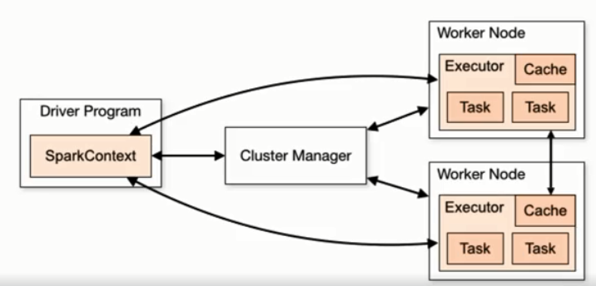

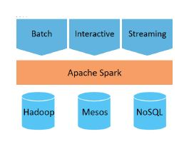

The graphic above shows the apps and systems that can be combined in Spark.

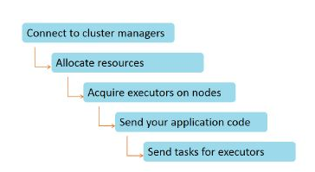

For running on a cluster, this object can connect to different types of cluster managers. We have already discussed different types of cluster managers. This allocates resources across applications. Once the system is connected, Spark acquires executors on nodes in the cluster. Executors are the processes that store data for applications and run computations. Then, it sends the application code to executors. At the end, SparkContext sends tasks for executors to run.

sc - > SparkContext

sqlCtx -> SQLContext

**To create RDD:**

>>>sc.parallelize(range(1,100)) 🡺 this will not return any result as it is lazy and it will not return the RDD.

>>> sc.parallelize(range(1,1000)).first() -> reaches spark and returns the result in RDD.

o/p: 1

>>>list2 = sc.parallelize(range(1,1000)) 🡺 creating RDD

>>>list2.map(lambda x: x*10).first() 🡺 map syntax is different from python. In spark map is a method.

o/p: 10

>>>list2.reduce(lambda x,y : x+y)

o/p: 499500

>>> list2.filter(lambda x : x%100 == 0).collect() 🡺 collect is also RDD method

o/p : [100,200,300,400,….900]

>>> list2.filter(lambda x : x%100 == 0).take(5)

o/p : [100,200,300,400,500]

**Transformations Vs Actions:**

**We divide RDD methods into two kinds:**

1. **Transformation:**
   1. Return another RDD
   2. Are not really performed until an action is called(lazy)
   3. Eg:
      1. .map(f)
      2. .filter(f)
      3. .flatmap(f)
2. **Actions:**
   1. Returns a value other than an RDD
   2. Are performed immediately
   3. Eg:
      1. .reduce(f)
      2. .take(n)
      3. .collect(n)
      4. .sum()

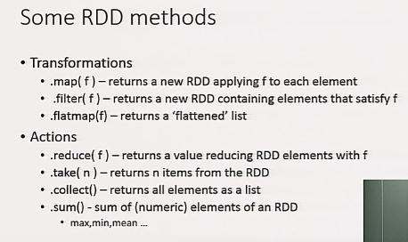

More egs:

>>>rdd1 = sc.parallelize(range(1,100))

>>>rdd1.map(lambda x:x*x).sum()

>>>rdd1.map(lambda x:x*x).max()

>>>rdd1.map(lambda x:x*x).min()

>>>rdd1.map(lambda x:x*x).mean()

>>>rdd1.filter(lambda x: x%2 ==0) .tale(5)

Get an RDD with number 1 to 10

>>>rdd1 = sc.parallelize(range(1,10))

Get the numbers divisible by 3

>>>rdd1 = sc.parallelize(range(1,10)).filter(lambda x: x%3 ==0).collect()

Get the product of those elements.

>>>rdd1 = sc.parallelize(range(1,10)).filter(lambda x: x%3 ==0).reduce(lamba x,y: x*y)

**Reading files:**

Eg:

>>>People = sc.textFile(“/data/people.txt”)

>>>People.first()

o/p: returns the first line from the text..with \t tab delimiter in between

[u’aaaa’\t’bbbb’\t’cccc’]

>>>People.map(lamba x:x.split(‘\t’)).first()

[u’aaaa’, u’bbbb’,u’cccc’]

**Tuples and ReduceByKey: (Groupby in sql)**

People contains Name |Gender|Age|Favourite language

In spark tuples contains <key,value>

>>>People = sc.textFile(“/data/people.txt”).map(lambda x:x.split(‘t))

**>>>**People.take(3)

Find number of people by gender:

>>>People.map(lambda t: (t[1],1)).reduceByKey(lambda x,y:x+y).collect()

o/p: [(u’M’,3),(u’F’,3)]

Find number of people by favourite programming language:

>>>People.map(lamba x: (x[3],1)).reduceByKey(lambda x,y : x+y).collect()

o/p : [(u‘Python’,3=4),(u’C#’,3)]

Find youngest person by gender:

>>> People.map(lambda t: (t[1],int(t[2])).reduceByKey(lambda x,y:min(x,y)).collect()

There is no persistent RDD’s, you need to run the query and create RDD whenever required.

**Joins:**

* Allows us to combine 2 different RDDs
* Each RDD is of form <k,V) (Key and Value)
* Result is of the form <k,<v1,v2>>
* Joins only on equal keys

RDD1.join(RDD2).first() 🡺 returns the first result

o/p: (k1 , (V1,V2))

**Spark :**

#spark context creation

conf = SparkConf().setAppName(appName).setMaster(master)

sc = SparkContext(conf=conf)

#sqlcontext creation

sqlcontext = SQLContext(sc)

import pandas as pd

mtcars = pd.read_csv("xxxx.csv",header = True)

#Spark dataframe creation

sdf = sqlcontext.createDataFrame(mtcars)

sdf.printSchema()

sdf.show(5)

sdf.filter(sdf['wt']>10).show(5)

sdf.withColumn(sdf['newcol'],sdf['wt]*5).show(5)

sdf.groupby(['cyl']).agg({"wt":"AVG"}).show(5)

sdf.groupby(['cyl']).agg({"wt": "count"}).sort("count(wt)".ascending = True).show(5)

# running SQL queries

sdf.registerTempTables("cars")

new_df = sqlcontext.sql("select gear from cars where cyl >4 and cyl <= 9")

new_df.show(5)

* When RDD is created, a direct acyclic graph(DAG)(graph of the business logic) is created. This is called transformation. During every transformation operation, only graph gets updated.
* RDD is immutable.
* The notion here is that the graphs can be replayed on nodes that need to get back to the state it was before it went offline - thus providing fault tolerance.
* transformations return a pointer to the RDD created and actions return values that comes from the action.

**3 ways to create RDD:**

1. using sc.parallelize(data) 🡺 data can be any existing data.
2. Using external or internal datasets from Hadoop/textfile/Cassandra etc , sc.textFile(“sdfdfdfd”)
3. Using transformations like filter creating another RDD.

**RDD Persistence:**

Describes the different storage level of caching.

2 methods of RDD persistence:

1. persist()
2. cache() 🡺 stores in-memory

RDD variable types:

1. Broadcast variable
   1. Provides read-only copy of variable to all workers to work parallely.
2. Accumulator variable
   1. Variables are added through associative operators.
   2. Only Driver can read the accumulator variable.
   3. Used for implementing counters and sum

Good link for persistence, Broadcast, Accumulator: <http://vishnuviswanath.com/spark_rdd_part2.html>

Good ref link:

[**https://gerardnico.com/wiki/db/spark/rdd**](https://gerardnico.com/wiki/db/spark/rdd)

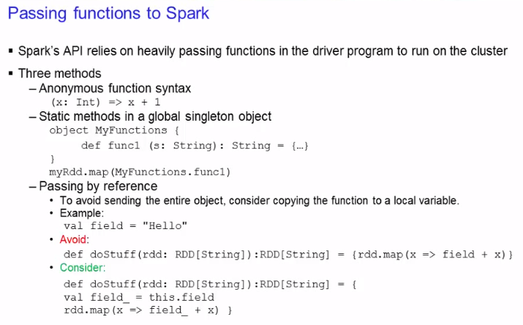

**Cloudera:**

Cloudera manager is the API. We have a url to access cloudera manager. We can manage and view the cluster and hosts details like CPU, current status etc.

Within each chart, there is chart builder option in settings, where we can get the query to fetch the metric information from cloudera into our application.

We can also use cloudera documentation to fetch each of the metrics other than quering from cloudera manager API in Java.

**Apache Hadoop: Hortonworks**

Ambari API is used for hortonworks. We have curl command to query the API and return to Java. We can also use the specific API links in browser and fetch the json format string output and use in Java for frontend UI.

**Details needed:**

Ambari login

Cloudera login

Documentation

Hadoop api

**Spark Dataframes:**

From pyspark.sql import SparkSession # Creating spark session

spark = SparkSession.builder.appname(‘Basics’).getOrCreate()

df = spark.read.json(“filename.json”)

df.show() 🡺 will print the values

df.printSchema() 🡺 prints the summary of the dataframe

df.columns 🡺 displays the column names

df.describe() 🡺 just diplays the dataframe as type and the columns with datatype.

df.describe().show() 🡺 displays the statistical summary of numerical columns

**creating own schema:**

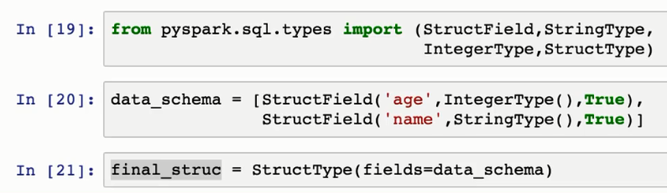

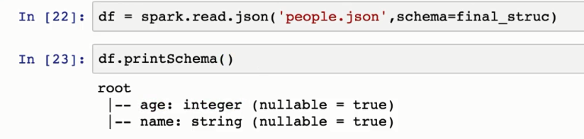

spark.read.csv 🡺 has a parmater called inferSchema which should be set to True to cary forward the Schema info from csv. This option is not in read.json.

df[‘age’] 🡺 will return age as a column

df.select(‘age’).show 🡺 will return a dataframe with age as column.

df.head(2) 🡺 will return first 2 rows.

df.withColumn(“New_age”,age*2).show() 🡺 creates a new column with age*2 as value, inplace is not true, you need to manually assign it to new variable.

df.withColumnRenamed(“age”, “new_name_age”) 🡺 renames age column with new_name_age. Inplace is true by default.

df.createOrReplaceTempView(‘people’) 🡺 creates a temp sql view based on the df.

results = spark.sql(“Select * from people”)

results.show()

In spark to filter entries based on multiple conditions & is used for and, | used for or and ~ used for not

df.filter(df[‘close’]>200).select(‘open’).show() 🡺 filters the data based on close column value > 200 and displays open column alone

df.filter( (df[‘close’]>200) & (df[‘open’]<500)).select(“volumne”).show() 🡺 adding multiple conditions. If & , | or ~ is used, then the conditions should be covered within ().

**Difference between .collect() .show():**

.show() just displays the output in screen but .collect() returns list of row object which can be assigned to a variable for later use.

Returned row object can be converted to dictionary using asDict()

df.groupBy(‘company’).mean().show() 🡺 displays the average sales value based on company.

**Aggregagte functions:**

count(), max(), min(), sum()

df.agg({‘Sales’ : ‘sum’}).show() 🡪 This is other technique of aggregation. It prints sum of Sales column value.

(or)

df.groupBy(‘Sales’).sum().show()

from pyspark.sql.functions import countDistinct, avg, stddev

df.select(countDistinct(‘Sales’)).show() 🡺 returns distinct Sales count

df.select(avg(‘Sales’)).show() 🡺 returns avg sales

df.select(avg(‘Sales’).alias(“Average Sales”)).show() 🡺 adding alias to the output

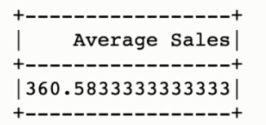

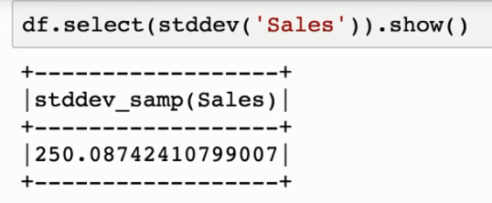

**#format_numbers**

from spark.sql.functions import format_number

df.select(stddev(‘Sales’)).show() 🡺 returns standard deviation of Sales column

sales_std = df.select(stddev(‘Sales’).alias(‘std’)) 🡺changing alias

sales_std.select(format_number(‘std’,2)).show() 🡺 changing the result with only 2 digits after decimal point.

**#order and sorting**

df.orderBy(‘Sales’).show() 🡺 sorts in ascending order on sales column

#decending order

df.orderBy(df[‘Sales’].desc()).show()

**#missing data**

from pyspark.sql import SparkSession

spark = SparkSession.builder.appName(“miss”).getOrCreate()

df = spark.read.csv(“ContainsNull.csv”, inferSchema = True, header = True)

df.show()

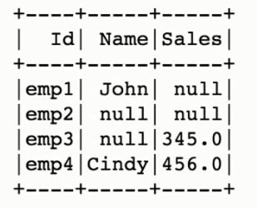

df.na.drop().show() 🡺 simply drops the colum with null values

df.na.drop(thresh =2).show() 🡺 should have atleast 2 non null values in each row. Emp2 is dropped because it has only 1 non-null entry in that row.

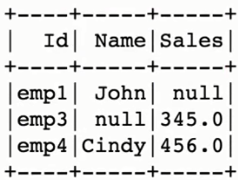

df.na.drop(how = ‘any’).show() 🡺 will drop the row if any of the value is null

df.na.drop(how=’all’).show()🡺 will drop the row if all the entries in that row is null.

df.na.drop(subset =[‘Sales’]).show() 🡺 considers only Sales column and drops all null

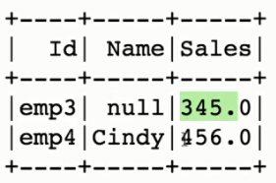

**#filling missing values**

df.na.fill(“Fill Value”).show() 🡺 this will fill the value as Fill Value only to string column as per the schema

df.na.fill(0).show() 🡺 this will fill 0 to the numeric column

df.na.fill(“No name”, subset =[‘Name’]).show() 🡺 we generally need to explicitly specify for which field

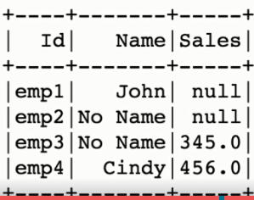

**#To fill missing values with mean**

from pyspark.sql.functions import mean

m = df.select(mean(df[‘Sales’])).collect() 🡺 fetching the mean value, since collect is used we get row object in list format

result = m[0][0] 🡺 first index is to fetch first element from list and second index [0] is to fetch the first value from the result

df.na.fill(result, ‘Sales’).show()

**#to put above steps in one line**

df.na.fill(df.select(mean(df[‘Sales’]).collect()[0][0], ‘Sales’).show()

**#dates and Timestamps**

from pyspark.sql import SparkSession

spark = SparkSession.builder.appName(“dates”).getOrCreate()

df = spark.read.csv(“apple_stock.csv”, inferSchema = True, header = True)

from pyspark.sql.functions import hour, month, year, dayofmonth, dayofyear, weekofyear, format_number, date_format

df.select(dayofmonth(df[‘Date’])).show() 🡺 returns day of month from the Date column

df.select(hour(df[‘Date’]).show() 🡺 return the hour of the date

df.select(month(df[‘Date’]).show() 🡺 returns the month

**# scenario is find out yearwise average closing price**

df.select(year(df[‘Date’])).show() 🡺 prints the year

new_df = df.withColumn(“Year”, year(df[‘Date’])) 🡺 creating a new column for Year

result = new_df.groupBy([‘Year’]).mean().select([“Year”,”avg(Close)”]) 🡺 group by year and calculating average of close

new_result = result.select([“Year”,format_number(“avg(Close)”,2).alias(“Avg Close”)) 🡺 formatting and aliasing

new_result.show()

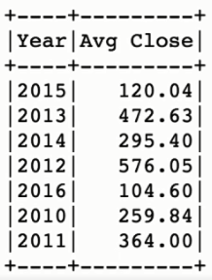

# To convert the datatype from string to float or int

df.printSchema() 🡺 u can identify the current data types

summary -> column is string

Open -> string

High -> String

Volume -> string

result = df.describe()

result.select([‘summary’], format_number(df[‘Open’].cast(‘float’),2).alias(“Open”),

format_number(df[‘High’].cast(‘float’),2).alias(“High”),

df[‘Volume’].cast(‘int).alias(‘Volume’)

)

# Select max and min value of Volume column

from pyspark.sql.functions import max, min

df.select([max(‘Volume’), min(‘Volume’)]).show()

or

df.agg({‘Volume’: ‘max’, ‘Volume’ : ‘min’}).show()

**#how many days close was less than 60 dollars:**

df.filter(df[‘Close’]<60).count() 🡺 python way

df.filter(‘Close <60’).count() 🡺 sql way

or

from pyspark.sql.functions import count

result = df.filter(df[‘Close’]<60)

result.select(count(‘Close’)).show() 🡺 dataframe output.

**#what percentage of time was the high greater than 80 dollars?**

Number of days high >80 /Total number of days

df.filter(df[‘High’]>80).count()/df.count()

**#pearson correlation between high and Volume**

from pyspark.sql.functions import corr

df.select(corr(‘High’,’Volume’)).show()

**#what is the max high per year?**

from pyspark.sql.functions import max, year

new_df = df.withColumn(“Year”, year(df[‘Date’]))

max_df = new_df.groupBy(‘Year’).max()

max_df.select([“Year”,”max(High)”]).show()

**#what is average close value for each month?**

from pyspark.sql.functions import mean, month

new_df = df.withColumn(“Month”, month(df[‘Date’]))

mean_df = new_df.select(“Month”,”Close”).groupBy(‘Month’).mean()

mean_df.select(“Month”, “avg(Close)”).orderBy(“Month”).show()

LIBSVM data format:

<https://stackoverflow.com/questions/40436694/libsvm-data-preparation-excel-data-to-libsvm-format>

The LIBSVM data format is given by:

<label> <index1>:<value1> <index2>:<value2> ...  
...  
...

More precisely a **sparse matrix**. If you specify a value for *each* index, you have a *dense* matrix, but if you only specify a few indices like <label> <5:value> <8:value>, only the indices 5 and 8 and of course label will have a custom value, all other values are set to 0. This is just for notational simplicity or to save space, since datasets can be huge.

**Linear Regresssion Model:**

from pyspark.sql import SparkSession

spark = SparkSession.builder.appName(“lr_example”).getOrCreate()

from pyspark.ml.regression import LinearRegression

data = spark.read.csv(“ecommerce_customers.csv”, inferSchema = True, header = True)

data.printSchema()

data.show()

for item in data.head(1)[0]:

print(item)

**# setting up dataframe for MLLib**

from pyspark.ml.linalg import Vectors

from pyspark.ml.feature import VectorAssembler

assembler = VectorAssembler(inputCols=[‘Avg Session Length’,’Time on App’,’Time on Website’,’Length of Membership’], outputCols = ‘features’)

output = assembler.transform(data)

output.printSchema()

output.head(1)

final_data = output.select(“features”,”Yearly Amount Spent”)

final_data.show()

**#train test split**

train_data, test_data = final_data.randomSplit([0.7.0.3])

train_data.describe().show()

test_data.describe().show()

lr = LinearRegression(labelcol =”Yearly Amount Spent”)

lr_model = lr.fit(train_data)

test_results = lr_model.evaluate(test_data)

test_results.residuals.show()

test_results.rootMeanSquaredError

test_results.r2

# to predict the result

Unlabeled_data = test_data.select(“features”)

Unlabeled_data.show()

Predictions = lr.model.transform(Unlabeled_data)

Predictions.show()

**Scala:**

<http://allaboutscala.com/tutorials/chapter-1-getting-familiar-intellij-ide/scala-environment-setup-install-scala-plugin-intellij/>

What are classes, traits, objects and package objects?  
I will go over these terms in more details in upcoming tutorials, but let's have a quick explanation for each one:

A class is conceptually similar to any other classes if you have done Java or .NET in that it is a placeholder for your methods or functions.

A trait is most certainly going to be a new term if you have never done any Scala. You can think of it as having similar behaviour to an interface in Java and or .NET in that it is a contract for your method or function signatures. However, a trait provides higher semantics than an interface which we will discuss later.

An object in Scala is a singleton! This means there will be only one instance of this object within your application/JVM. The [singleton pattern](https://en.wikipedia.org/wiki/Singleton_pattern) is such a commonly used pattern that Scala has built-in support for it.

A package object will also be a new term if you have never done any Scala. It is a placeholder where you can store and expose globally scoped objects and functions such as implicit conversion.

**Intellij project structure:**

<http://allaboutscala.com/tutorials/chapter-1-getting-familiar-intellij-ide/intellij-project-structure-getting-started-scala-project/>

**HIVE:**

**Creating table:**

CREATE TABLE IF NOT EXISTS my_sample_table (TimeStamp String, A float,

B float, C float)

COMMENT 'My Sample Table'

ROW FORMAT DELIMITED

FIELDS TERMINATED BY '\t'

LINES TERMINATED BY '\n'

STORED AS TEXTFILE;

**Loading data:**

LOAD DATA INPATH '/hbase/data/sample_data/sample_datafile.txt' OVERWRITE INTO TABLE my_sample_table;

**Default location of Hive tables:**

hdfs dfs -ls /user/hive/warehouse

**Inserting rows from one table to another: (without replacing .txt file from source)**

Insert into table sample_data select * from my_sample_table2;

**Changing location of table:**

CREATE TABLE IF NOT EXISTS sample_data ( TimeStamp String, A float,

B float, C float)

COMMENT 'sample table 2'

ROW FORMAT DELIMITED

FIELDS TERMINATED BY '\t'

LINES TERMINATED BY '\n'

STORED AS TEXTFILE LOCATION '/hbase/data/sample_data';

**What is Partitions?**

Hive Partitions is a way to organizes tables into partitions by dividing tables into different parts based on partition keys.

<https://www.guru99.com/hive-partitions-buckets-example.html>

Partitioning is the optimization technique in Hive which improves the performance significantly.

Good article : <https://data-flair.training/blogs/apache-hive-partitions/>

There are two types of Partitioning in Apache Hive-

* Static Partitioning
* Dynamic Partitioning

CREATE TABLE IF NOT EXISTS region_table ( TimeStamp String, A float,

B float, C float, Region String)

COMMENT 'Region Table'

ROW FORMAT DELIMITED

FIELDS TERMINATED BY '\t'

LINES TERMINATED BY '\n'

STORED AS TEXTFILE;

LOAD DATA LOCAL INPATH '/home/cloudera/Documents/VirtualDropbox/Region_datafile.txt' OVERWRITE INTO TABLE region_table;

create table region_part(timestamp String, a float, b float, c float) PARTITIONED BY(region String);

set hive.exec.dynamic.partition.mode =nonstrict

INSERT OVERWRITE TABLE region_part PARTITION(region) Select timestamp, a, b, c, region from region_table;



Hive file formats:

<https://acadgild.com/blog/apache-hive-file-formats>

**Bucketing:**

In [**Apache** **Hive**](https://data-flair.training/blogs/apache-hive-tutorial/), for decomposing table data sets into more manageable parts, it uses Hive Bucketing concept.

Partitioning works best on below scenarios:

– When there is the limited number of partitions.  
– Or, while partitions are of comparatively equal size.

Hence, some bigger countries will have large partitions (ex: 4-5 countries itself contributing 70-80% of total data). While small countries data will create small partitions (remaining all countries in the world may contribute to just 20-30 % of total data). Hence, at that time Partitioning will not be ideal.  
Then, to solve that problem of over partitioning, Hive offers Bucketing concept. It is another effective technique for decomposing table data sets into more manageable parts.

create table time_bucket (TimeStamp String, A float, B float, C float) comment 'Bucketed table'

partitioned by (Region String)

clustered by(TimeStamp) into 10 buckets

row format delimited

fields terminated by '\t'

lines terminated by '\n'

stored as textfile;

set hive.exec.dynamic.partition=true;

set hive.exec.dynamic.partition.mode =nonstrict;

set hive.enforce.bucketing =true;

Insert overwrite table time_bucket partition(region)

select * from region_table;

select * from time_bucket;

o/p:

In output, we can see 10 reducers and 1 mapper as we created 10 buckets

If you open the file path, you will see 10 bucket files under each partition.

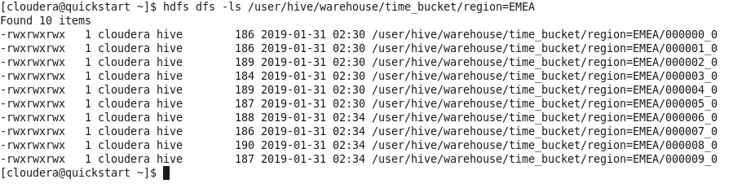

* Partitioning – Apache Hive organizes tables into partitions for grouping same type of data together based on a column or partition key. Each table in the hive can have one or more partition keys to identify a particular partition. Using partition we can make it faster to do queries on slices of the data.
* Bucketing – In Hive Tables or partition are subdivided into buckets based on the hash function of a column in the table to give extra structure to the data that may be used for more efficient queries.

Hive organizes tables into partitions. And it subdivides partition into buckets.

### **iii. Advantages and Disadvantages of Hive Partitioning & Bucketing**

Let us now discuss the pros and cons of Hive partitioning and Bucketing one by one-  
**a) Pros and Cons of Hive Partitioning**  
**Pros:**

* It distributes execution load horizontally.
* In partition faster execution of queries with the low volume of data takes place. For example, search population from Vatican City returns very fast instead of searching entire world population.

**Cons:**

* There is the possibility of too many small partition creations- too many directories.
* Partition is effective for low volume data. But there some queries like group by on high volume of data take a long time to execute. For example, grouping population of China will take a long time as compared to a grouping of the population in Vatican City.
* There is no need for searching entire table column for a single record.

**b) Pros and Cons of Hive Bucketing**  
**Pros:**

* It provides faster query response like portioning.
* In bucketing due to equal volumes of data in each partition, joins at Map side will be quicker.

**Cons:**

* We can define a number of buckets during table creation. But loading of an equal volume of data has to be done manually by programmers.

Hive Joins:

1. Common join or sort merge join -> very expensive as lot of shuffling
   1. when 2 large data tables need to do a join, there will be 2 different Mappers to sort these tables based on the join key and emit an intermediate file, and the Reducer will take the intermediate file as input file and do the real join work. This join mechanism (referred to as Common Join) is perfect with two large data size.
2. Map join or Auto map or Map side or Broadcast join
   1. if one the join tables is small enough to fit into the Mapper‚ A's memory, then there is no need to launch the Reducer. Actually, the Reducer stage is very expensive for the performance because the Map/Reduce framework needs to sort and merge the intermediate files. So the basic idea of Map Join is to hold the data of small table in Mapper‚A's memory and do the join work in Map stage, which saves the Reduce stage.
   2. 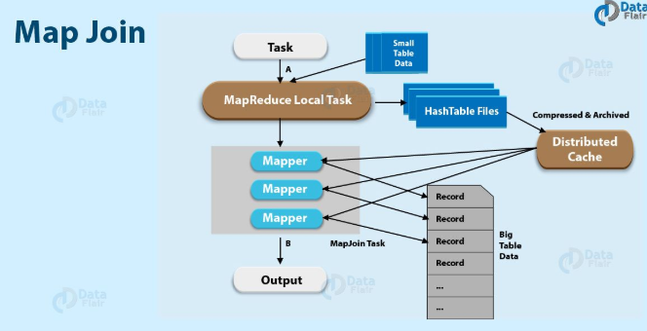
   3. Basically, before the original [MapReduce](https://data-flair.training/blogs/hadoop-mapreduce-tutorial/) task, its first step is to create a MapReduce local task. However, from [HDFS](https://data-flair.training/blogs/hadoop-hdfs-tutorial/) this map/reduce task read data of the small table. Further save it into an in-memory hash table, then into a hash table file. Afterward, it moves the hash table file to the [Hadoop](https://data-flair.training/blogs/install-and-configure-hadoop-2-7-x-on-ubuntu/) Distributed Cache while original join MapReduce task starts, which will populate the file to each mapper’s local disk. Hence, in this way, all the mapper can load this hash table file into the memory and then do the join in Map stage.
   4. So, let’s understand this with an example. let’s suppose, for a join with big table A and small table B, for every mapper for table A, Table B is read completely. Since the smaller table is loaded into memory at first. Afterward, join is performed in the map phase of the MapReduce job, no reducer is needed and reduce phase is skipped. However, map joins in Hive are way faster than the regular joins since no reducers are necessary.
   5. Below parameters should be set for map join

set hive.auto.convert.join.noconditionaltask = True

**Limitations of Map Join in Hive**

Below are some limitations of Map Side join in Hive:

1. First, the major restriction is, we can never convert Full outer joins to map-side joins.
2. However, it is possible to convert a left-outer join to a map-side join in the Hive. However, only possible since the right table that is to the right side of the join conditions, is lesser than 25 MB in size.
3. Also, we can convert a right-outer join to a map-side join in the Hive. Similarly, only possible if the left table size is lesser than 25 MB.

To View hive parameters, just type set ‘parameter name’:

Eg:

set hive.auto.convert.join.noconditionaltask.size;

Enforcing map join using hints:

select /*+ MAPJOIN(t1) */ t1.* from

my_sample_table2 t1 join region_table t2

on t1.c = t2.c and t2.region='EMEA';

**Bucket Map join:**

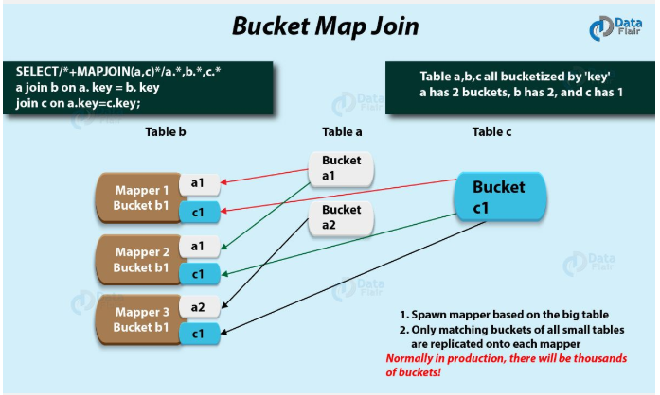

This parameter should be set to True.

set hive.optimize.bucketmapjoin = true

select /* +mapjoin(t2) */ t1.* from my_sample_table2 t1, region_table t2 where t1.timestamp=t2.timestamp;

**Skew join:**

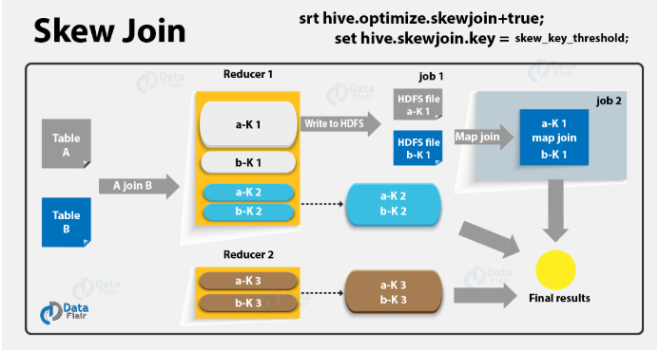

set hive.optimize.skewjoin=true;  
set hive.skewjoin.key=100000;

select t2.* from region_table t2, my_sample_table2 t1 where t1.timestamp = t2.timestamp;

**Sort Merge Bucket Join:**

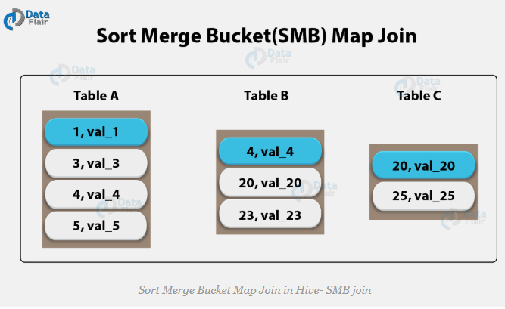

set hive.auto.convert.sortmerge.join=true;  
set hive.optimize.bucketmapjoin = true;  
set hive.optimize.bucketmapjoin.sortedmerge = true;  
set hive.auto.convert.sortmerge.join.noconditionaltask=true;

Hive has two types of tables which are as follows:

* Managed Table (Internal Table)
* External Table

**Hive Managed Tables-**  
It is also known an internal table. When we create a table in Hive, it by default manages the data. This means that Hive moves the data into its warehouse directory.  
**Hive External Tables-**  
We can also create an external table. It tells Hive to refer to the data that is at an existing location outside the warehouse directory.

**Group by:**

select region, count(*) from region_table group by region;

Hive Optimization Techniques:

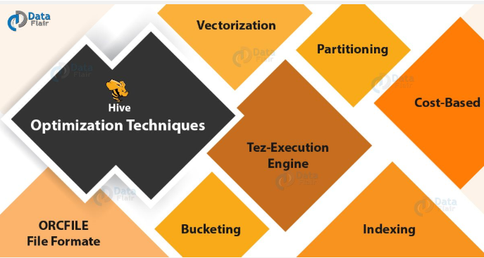

* Tez Execution Engine – Hive Optimization Techniques, to increase the Hive performance of our hive query by using our execution engine as Tez. On defining Tez, it is a new application framework built on [**Hadoop Yarn**](https://data-flair.training/blogs/hadoop-yarn-tutorial/). That executes complex-directed acyclic graphs of general data processing tasks. However, we can consider it to be a much more flexible and powerful successor to the map-reduce framework.
* ORCFILE File Formate – Hive Optimization Techniques, if we use appropriate file format based on data. It will drastically increase our query performance. Basically, for increasing your query performance ORC file format is best suitable. Here, ORC refers to **Optimized Row Columnar**. That implies we can store data in an optimized way than the other file formats.  
  To be more specific, ORC reduces the size of the original data up to 75%.

Hence, data processing speed also increases. On comparing to Text, Sequence and RC file formats, ORC shows better performance. Basically, it contains rows data in groups. Such as Stripes along with a file footer.  Therefore, we can say when Hive is processing the data ORC format improves the performance.

* Hive Partition – Hive Optimization Techniques, Hive reads all the data in the directory Without partitioning. Further, it applies the query filters on it.  Since all data has to be read this is a slow as well as expensive.  
    
  Also, users need to filter the data on specific column values frequently. Although, users need to understand the domain of the data on which they are doing analysis, to apply the partitioning in the Hive.  
    
  Basically, by Partitioning all the entries for the various columns of the dataset are segregated and stored in their respective partition. Hence, While we write the query to fetch the values from the table, only the required partitions of the table are queried. Thus it reduces the time taken by the query to yield the result.
* [**Bucketing in Hive**](https://data-flair.training/blogs/bucketing-in-hive/) – Hive Optimization Techniques, let’s suppose a scenario. At times, there is a huge dataset available. However, after partitioning on a particular field or fields, the partitioned file size doesn’t match with the actual expectation and remains huge. Still, we want to manage the partition results into different parts. Thus, to solve this issue of partitioning, Hive offers Bucketing concept. Basically,  that allows the user to divide table data sets into more manageable parts.  
    
  Hence, to maintain parts that are more manageable we can use Bucketing. Through it, the user can set the size of the manageable parts or Buckets too.
* Vectorization In Hive – Hive Optimization Techniques, to improve the performance of operations we use Vectorized query execution. Here operations refer to scans, aggregations, filters, and joins. It happens by performing them in batches of 1024 rows at once instead of single row each time.  
    
  However, this feature is introduced in Hive 0.13. It significantly improves query execution time, and is easily enabled with two parameters settings:  
    
  set hive.vectorized.execution = true  
    
  set hive.vectorized.execution.enabled = true
* Hive Index – Hive Optimization Techniques, one of the best ways is Indexing. To increase your query performance indexing will definitely help. Basically, for the original table use of indexing will create a separate called index table which acts as a reference.  
    
  As we know, there are many numbers of rows and columns, in a[**Hive table**](https://data-flair.training/blogs/hive-internal-tables-vs-external-tables-comparison/). Basically, it will take a large amount of time if we want to perform queries only on some columns without indexing. Because queries will be executed on all the columns present in the table.  
    
  Moreover,  there is no need for the query to scan all the rows in the table while we perform a query on a table that has an index, it turned out as the major advantage of using indexing. Further, it checks the index first and then goes to the particular column and performs the operation.

**Sharding:**

Ref link: <http://hive.rinoy.in/sharding/>

Sharding is the process of storing data records across multiple machines and it is MongoDB’s approach to meeting the demands of data growth.

When the table in Regionserver grows beyond a pre-configured limit, the Hbase system splits the table into another regionserver. This is called sharding.

You can think of sharding as the decision to put your data on multiple machines, and consistent hashing as one of many methods of determining which machine any particular piece of data goes to.

**Shards**  
-> Shards are used to store data. They provide high availability and data consistency. In production environment each shard is a separate replica set.

**Hash function:**

 A hash function reads an input string and produces a fixed-size alphanumeric output string. Since the output is generally uniquely (very little chance of collision) mapping to the input string, the hashed value is quite often used to secure columns, which are the unique identifiers for joining or comparing data. Built-in function, such as md5(...), sha1(...), and sha2(...), can be used for data hashing in HQL:

**> SELECT**   
**> name,**   
**> md5(name) as md5_name,** -- 128 bit  
**> sha1(name) as sha1_name,** -- 160 bit  
**> sha2(name, 256) as sha2_name** -- 256 bit  
**> FROM employee;**  
**+---------+----------------------------------+**  
**| name | md5_name |**  
**+---------+----------------------------------+**  
**| Michael | 3e06fa3927cbdf4e9d93ba4541acce86 |**  
**| Will | 2b80f09163f60ce1774b438e605eb1f9 |**  
**| Shelley | e47e592945f28b3c3891ee9d27ec6b61 |**  
**| Lucy | 80eb0e612760f756547b660c4c71ba7d |**  
**+---------+----------------------------------+**  
**+------------------------------------------+**  
**| sha1_name |**  
**+------------------------------------------+**  
**| f8c38b2167c0ab6d7c720e47c2139428d77d8b6a |**  
**| 3e3e5802bd4cad8e29e144b515307d8204a3202a |**  
**| 2d4cab849437156354d24c9564958e6581711d08 |**  
**| c5c8f32bdf9998e0f692231f4f969085c8dc225b |**  
**+------------------------------------------+**  
**+------------------------------------------------------------------+**  
**| sha2_name |**  
**+------------------------------------------------------------------+**  
**| f089eaef57aba315bc0e1455985c0c8e40c247f073ce1f4c5a1f8ffde8773176 |**  
**| 6cef4ccc1019d6cee6b9cad39d49cabf808ba2e0665d5832b70c44c09c2dfae0 |**  
**| 1e8b342dde7c90cfbc9634c777b6b59388b6a4bd14274adffbfaeed4b329b26e |**  
**| a3fa95a3b95d421c316f1a9b12c88edcc47896705976764d2652425de98f0c4f |**  
**+------------------------------------------------------------------+**  
**4 rows selected (0.344 seconds)**

**HBASE:**

Hbase is nosql columnar database where data gets stored in key value pairs of byte arrays.

For HBase to work, Hmaster service should be on.

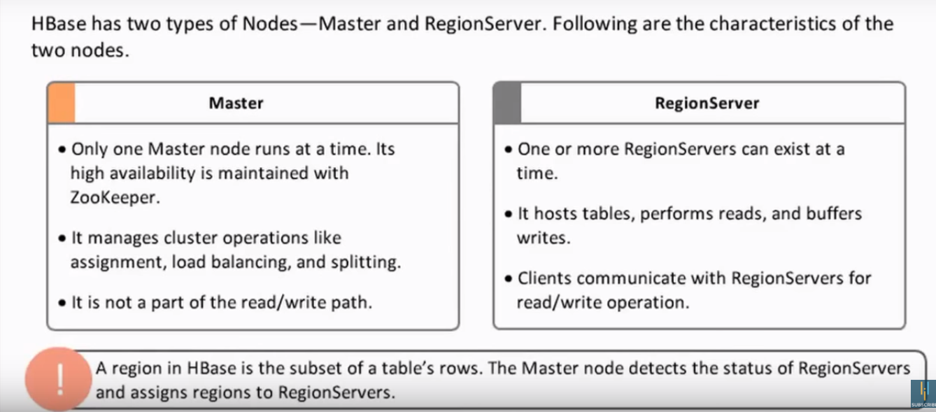

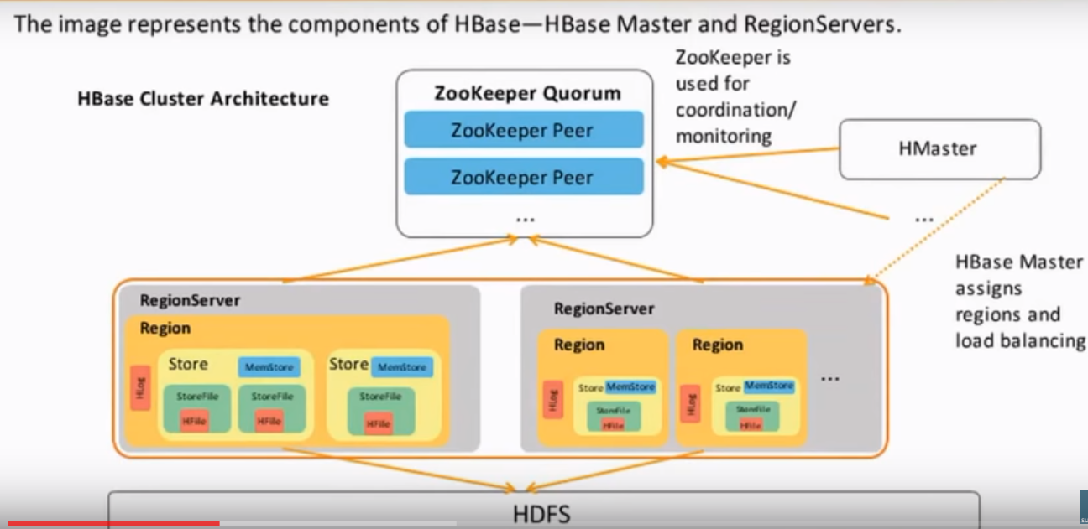

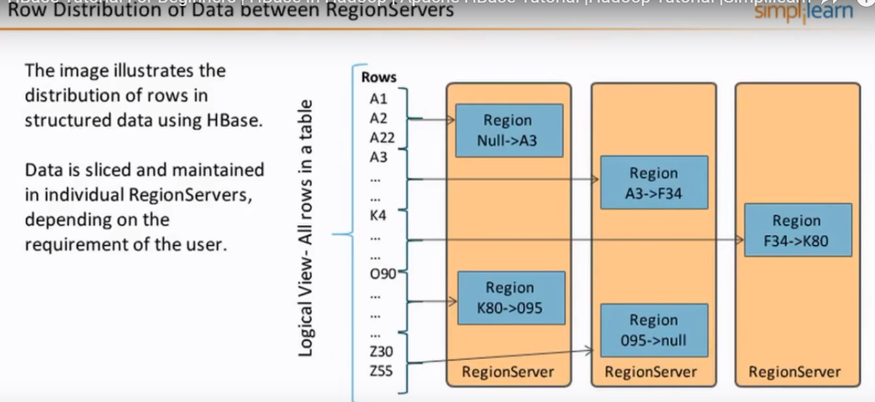

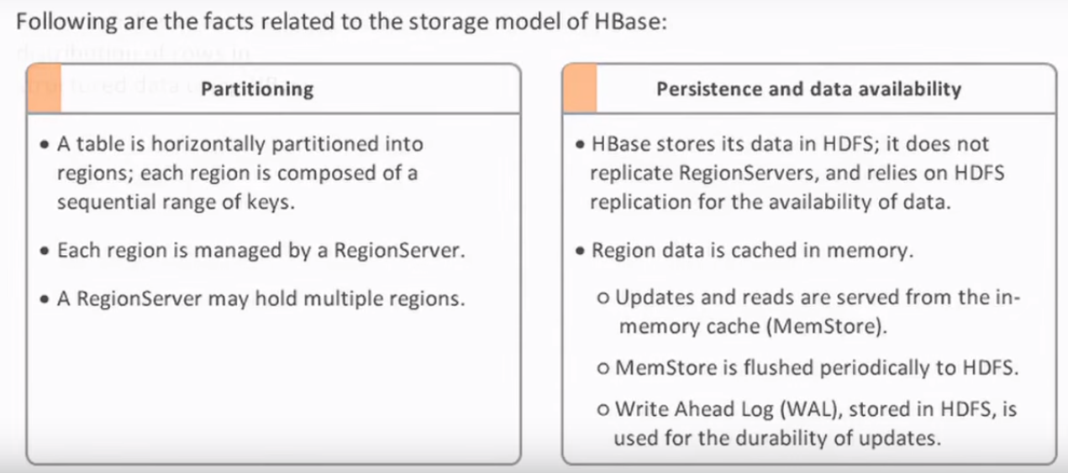

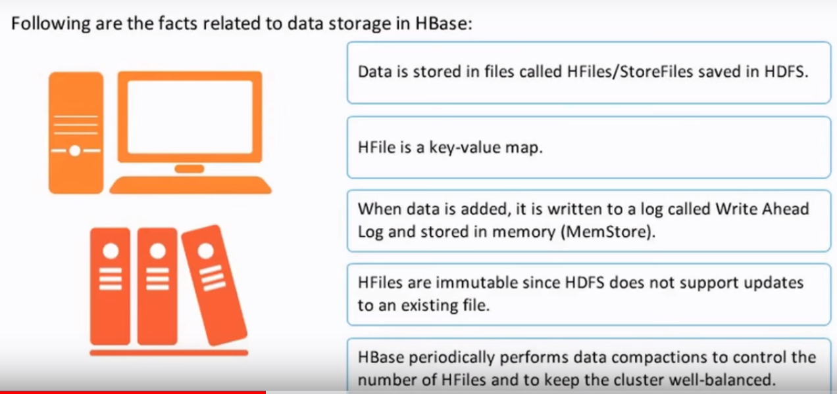

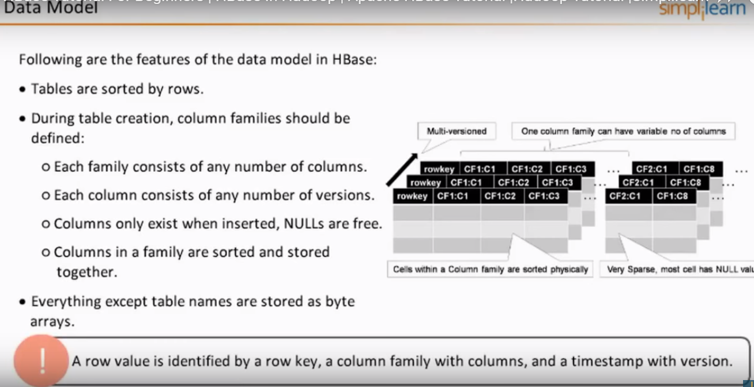

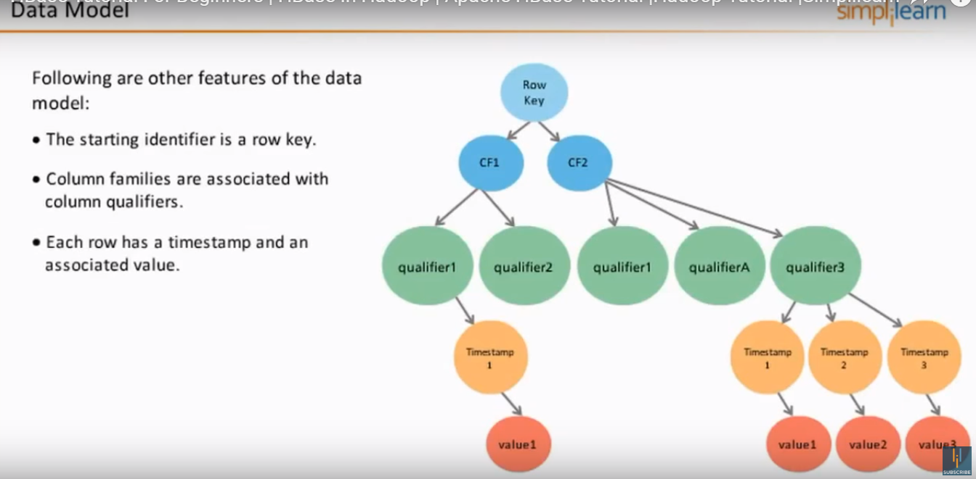

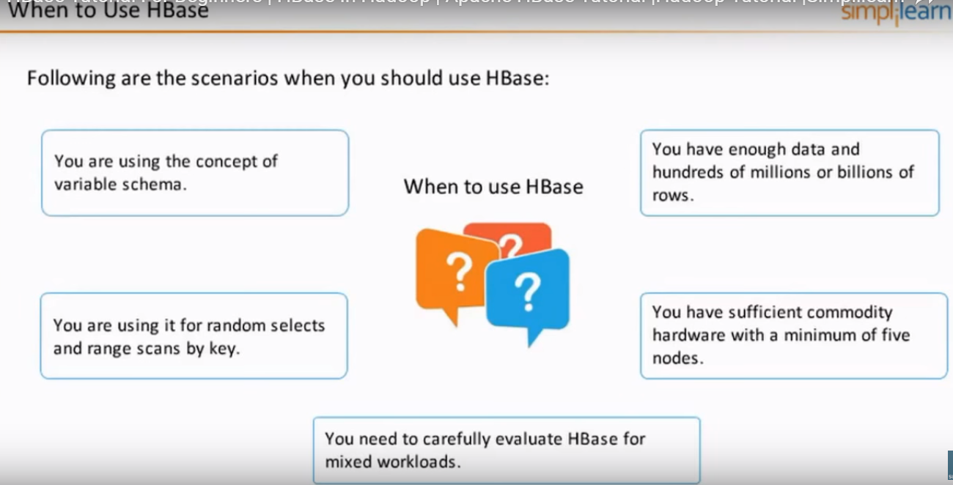

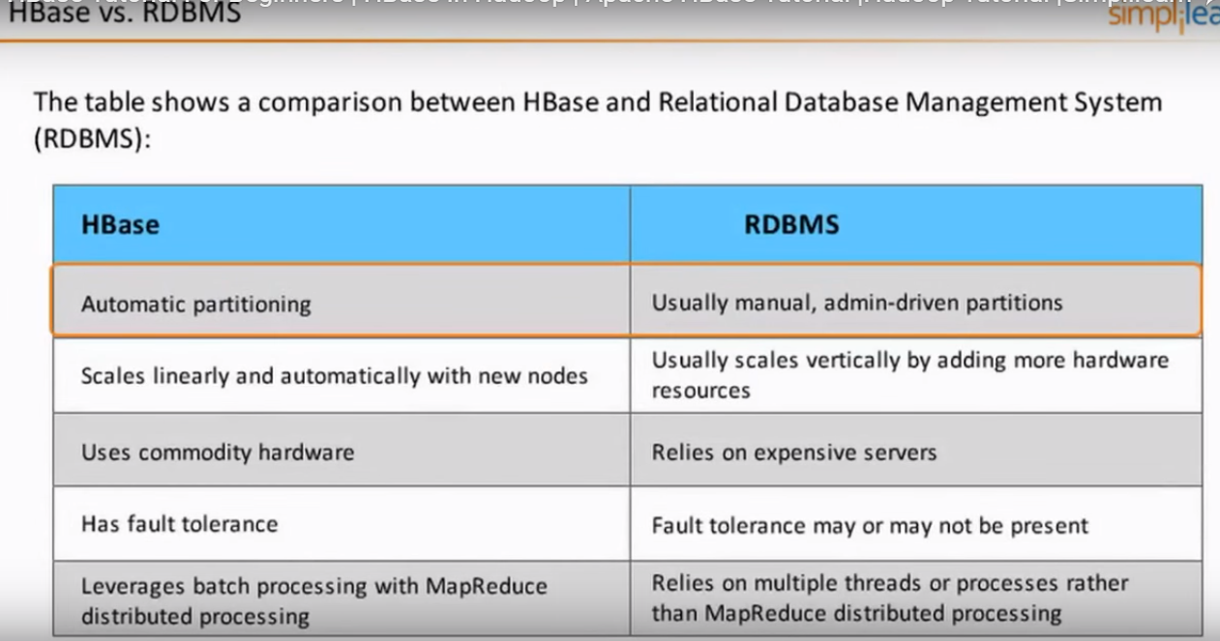

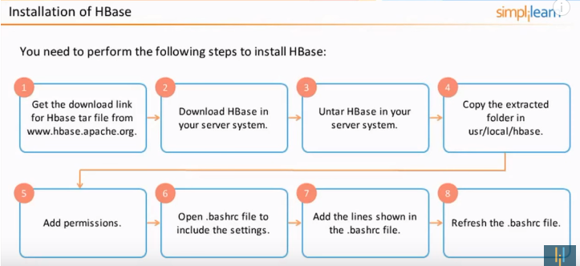

Link: <https://www.youtube.com/watch?v=eEnLwezJzMI&t=454s>

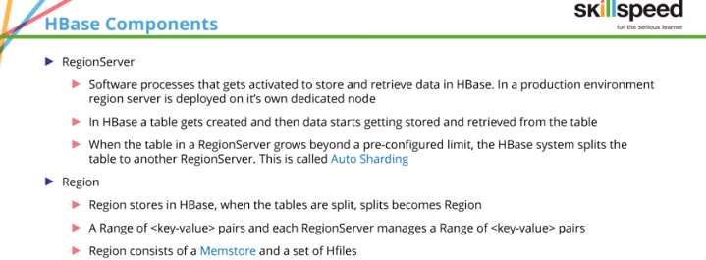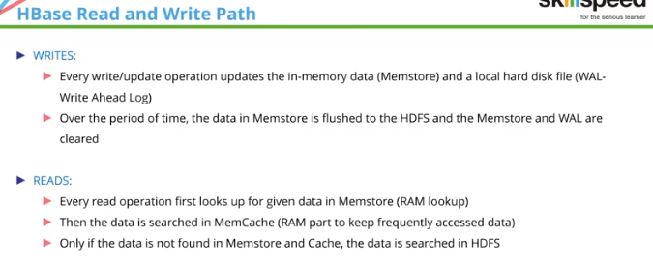

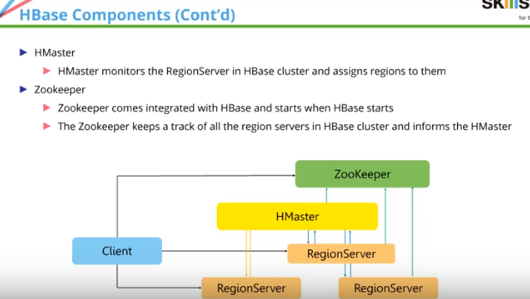

Hbase commands:

Hbase shell -> opens hbase shell

Version -> will print hbase verision

List -> will print the list of hbase objects like tables

Create ‘customer,’address’,’order’ -> creates a table customer with column families address and order.

Put ‘customer’,’john’,’address:city’,’chennai’ -> insert record

Scan ‘customer’ -> displays all rows

Get ‘customer’,’john’ -> retrieves john records

Disable ‘customet’ -> disables table

Enable ‘customer’ -> enables table

Alter ‘customer’,’delete’=>’address’ -> deletes address column family

alter 'customer', {NAME=>'address'} -> creates new column family

count ‘customer’ 🡪 returns number of keys in table

delete ‘customer’ -> Will not work

drop ‘customer’ ->need to disable first and then drop to delete a table.

**Versioning:** keeps track of mentioned number of versions for each column. Lets say version is 2, we can see past 2 values for the same row key under the same column. By default version is 1. We can modify it explicitly.

**Creating table with specified versions:**

Create ‘booking’, {NAME=>’Personal’, versions>3}

Altering column family with specified versions

alter 'customer',NAME=>'address',VERSIONS=>2

put 'customer','john','address:city',’chennai’

put 'customer','john','address:city','coimbatore' ->[inserting another value for the same row key john

scan ‘customer’ ->[will show the latest value only which is Coimbatore ]

scan ‘customer’,{COLUMN=>’address:city’,VERSIONS=>2} ->[will show both the versions]

**Note:** since versioning added to column family address, all the columns within this family will have 2 versions.

Scan ‘customer’,VERSIONS=>2 ->[This will print all past 2 versions of all columns under the column family for which versioning is enabled]

SCD -> Slowly Changing Dimensions

<https://wearerealitygames.com/2017/04/14/designing-a-data-warehouse-on-hadoop-2/>

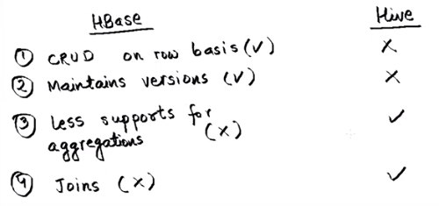

How to join HBASE table with hive:

Option 1 : Convert HBASe table to hive table and then perform join. But, this transfer takes time and also if hbase table is 1TB, we will have another hive table of 1tb due to data duplication.

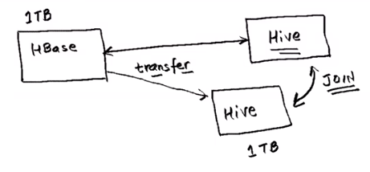

Option 2 : Nosql storage handler.

Instead of hive managed table, hive external table will be created as that will just have pointer to the data instead of having duplicate data storage in HDFS and hbase table is transferred to hive table and then joined with the hive managed table. HBASE to hive data transfer happens through a connected called nosql storage handler. Mapping has to be made in the connector as not all columns of hbase would not be needed on hive.

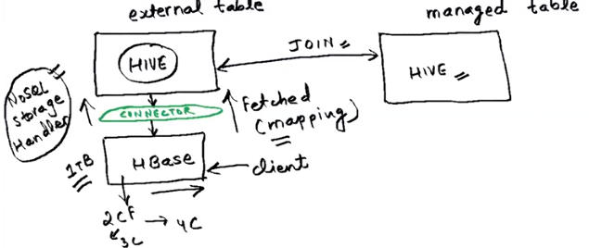

**Compaction:**

To reduce the storage and reduce the number of disks seeks needed for a read, HBase combines HFiles. This entire process is what we call compaction. It selects few HFiles from a region and combines them.

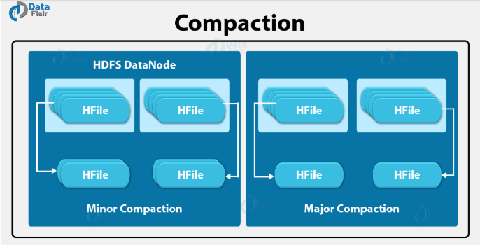

**Minor compaction:**

As you can see in the image, HBase picks smaller HFiles automatically and then recommits them to bigger HFiles. This process is what we call Minor Compaction. For committing smaller HFiles to bigger HFiles, it performs merge sort.

**Major compaction:**

HBase merges and recommits the smaller HFiles of a region to a new HFile, in Major compaction, as you can see in the image. Here, in the new HFile, the same column families are placed together. In this process, it drops deleted as well as expired cell.  
However, it is a possibility that input-output disks and network traffic might get congested during this process. Hence, generally during low peak load timings, it is scheduled.

**HBase Operations:**

Basically, in both data read and write operation of HBase, there are two major components which play a vital role in it, like HFile and META Table,

**HFile:**

A basic level [**HBase architecture**](https://data-flair.training/blogs/hbase-architecture/) where the tables exist in physical form is what we call HFile.

**META table:**

HBase Read operation needs to know which HRegion server has to be accessed for reading actual data, so, we use META Table in Read operation of HBase.  
Moreover, the META Table will have the updated data because, after every Write process, this table is updated for the next Read.

* An HBase table which keeps a list of all regions in the system is META Table.
* It is like a binary tree.

Its structure is as follows:

Key: Region start key, Region id  
Values: RegionServer

**Difference between alter and alter_async command:**

Only one difference between alter command and  alter_async is, alter_async does not wait for all regions to receive the schema changes.

MSLAB refers to Memstore-Local Allocation Buffer.

**Difference between Hadoop and Teradata:**

<https://www.educba.com/hadoop-vs-teradata/>

**Parquet file format:**

<https://acadgild.com/blog/parquet-file-format-hadoop>

**Azure Data Lake : cloud based solution for integrating and automating ETL and ELT tasks.**

Modern data movement and processing

Cloud form of SSIS for doing ETL and ELT jobs.

Author tab in Azure Data lake 2.0 provides an environment which is similar to SSIS control flow tab.

Ref link: <https://www.youtube.com/watch?v=KrB2JcTu21w&feature=youtu.be>

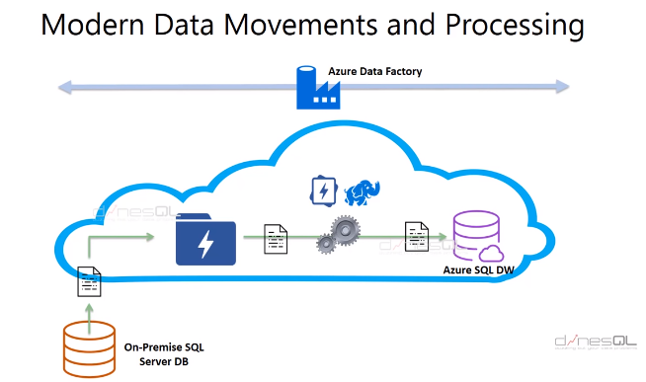

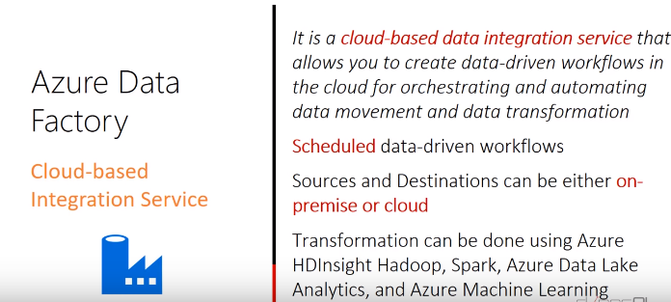

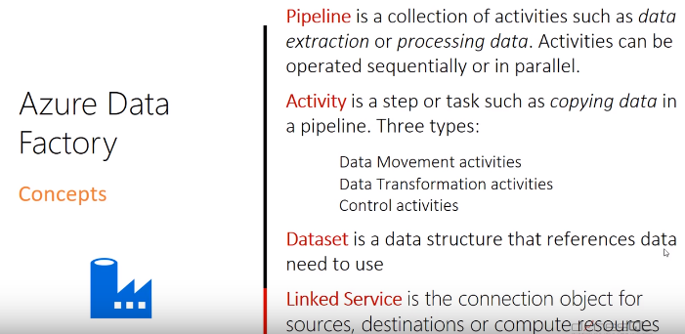

Integration Runtime is kind of bridge between public(Azure Data factory) and private(on premise database)

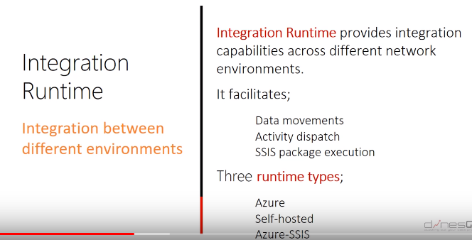

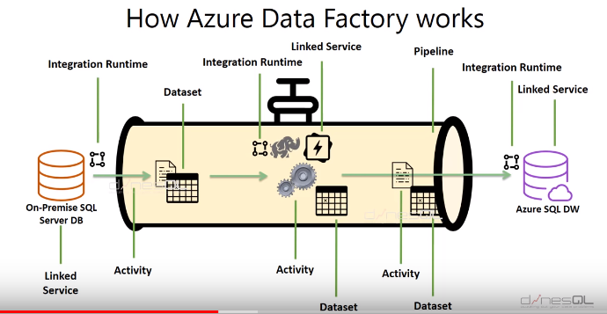

Difference between Azure Data lake and Azure Datawarehouse

|  |  |
| --- | --- |
| **Data Lake** | **Data warehouse** |
| [Data lakes](https://www.talend.com/resources/what-is-data-lake/) and [data warehouses](https://www.talend.com/resources/what-is-data-warehouse/) are both widely used for storing [big data](https://www.talend.com/products/big-data/), but they are not interchangeable terms. A data lake is a vast pool of raw data, the purpose for which is not yet defined. | A data warehouse is a repository for structured, filtered data that has already been processed for a specific purpose. |

